Sustainable Supply Chain Performance Dashboard using Power BI

Name – Vitthal Gautam

Step: -1 Click on Transform data in home tab under queries section

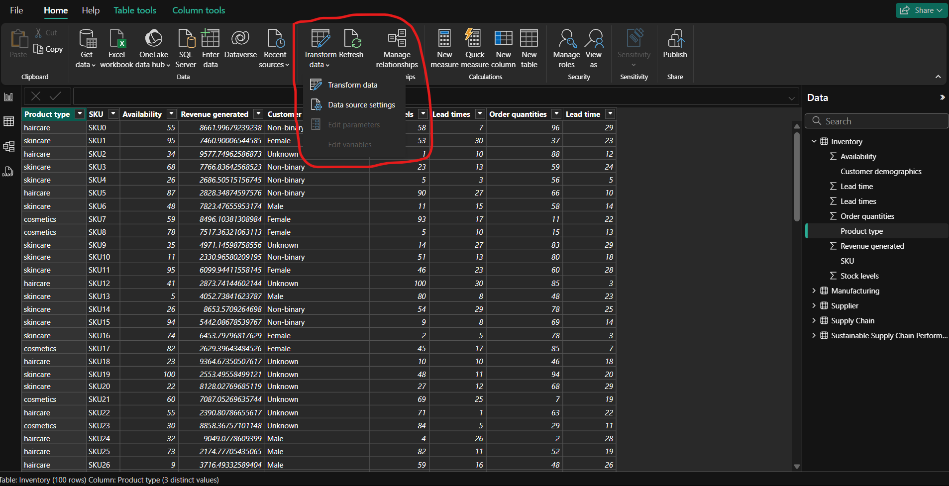

Step: -2 now on transform data window, in view tab select show whitespaces, Column quality in data preview

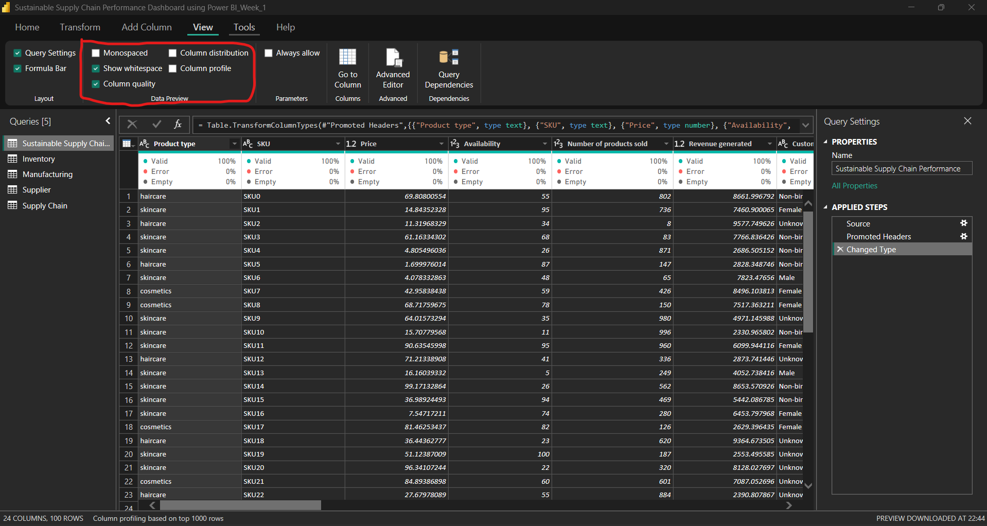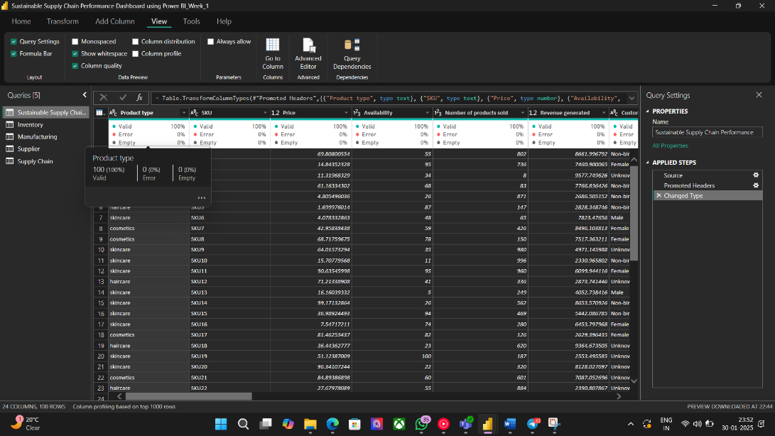

Step: - 3 Right click on table icon on top left corner and select remove duplicate option to remove duplicate entries in whole data table or you can do for individual column also

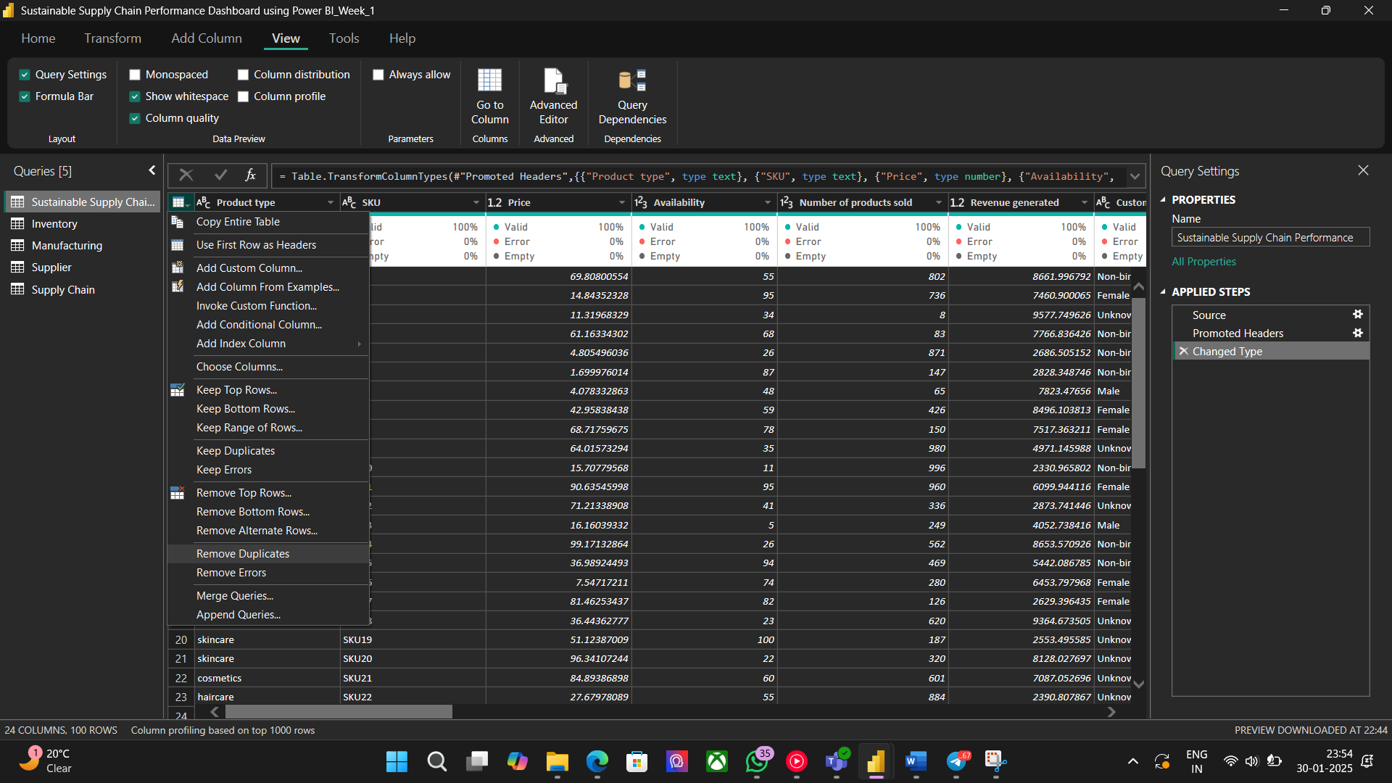

Step: - 4 Now on transform tab click on group by option, new tab will appear now select (basic) Select column on which operation to perform now name new column and select which operation to perform in operation tab new column will be added now

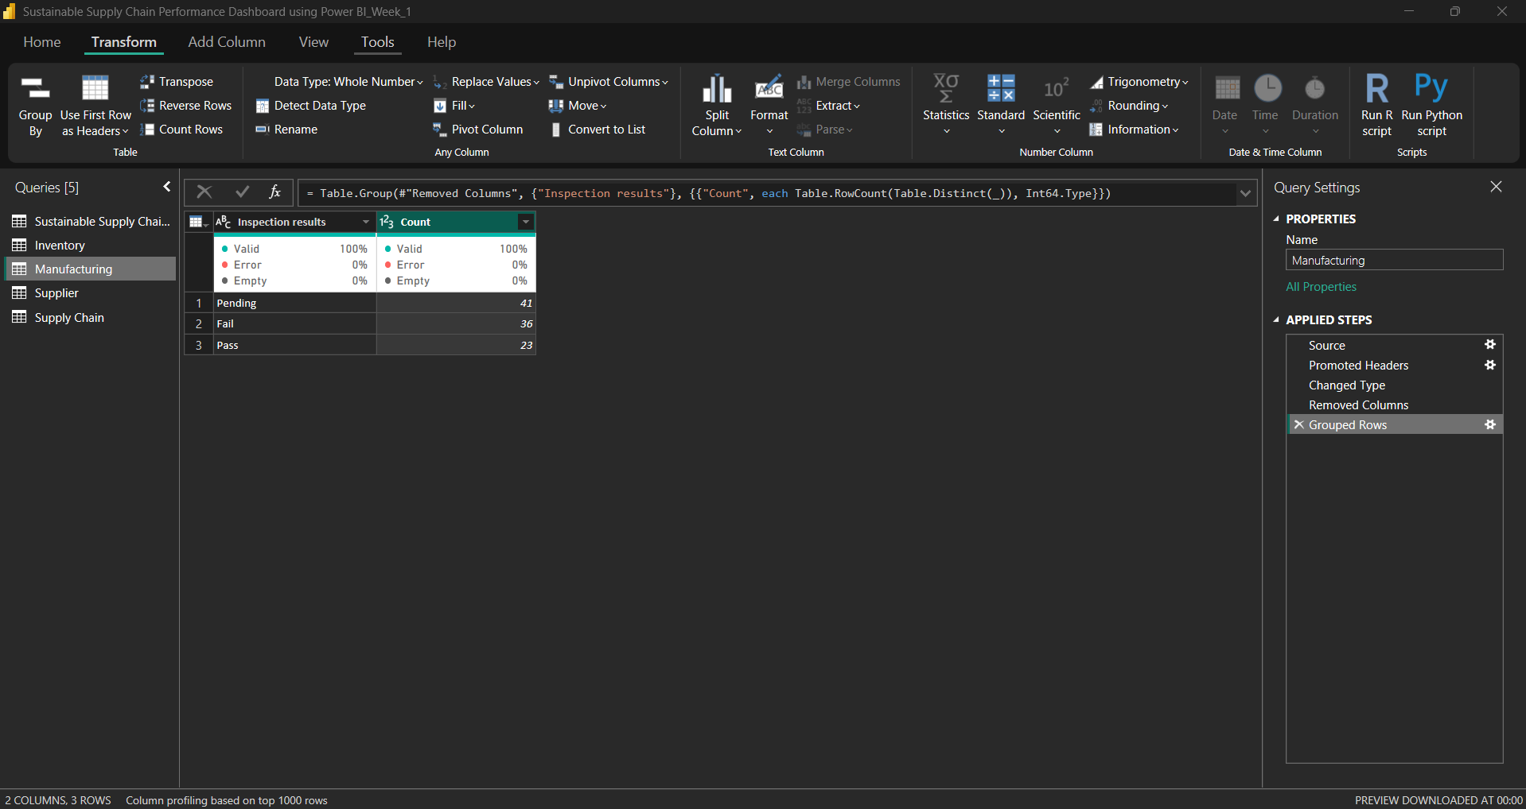

Step: - 5 You can add new relationship by drag and drop one unique column to another table. By selecting make this relationship active, we can active the relation b/w the tables

